Digital Design Diploma

# **Assignment 1**

# **Combinational Circuit Design**

|  |  |
| --- | --- |
| **Name** | كريم حسن عاطف علي |
| **Group** | G2 |

**Submitted to: Eng. Kareem Waseem**

**1)**

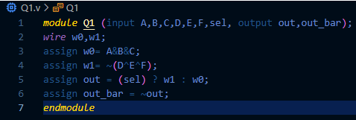

Figure 1: Q1 Code

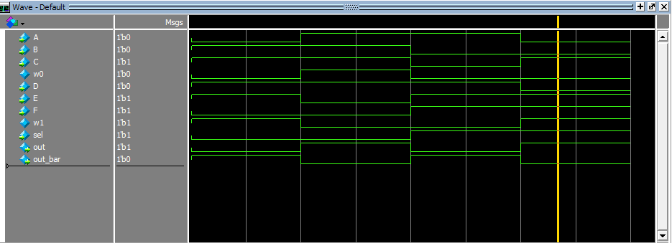

Figure2: Q1 Wave

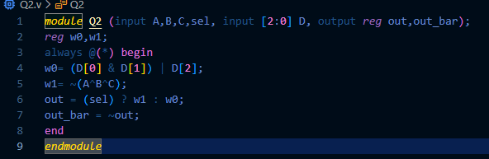**2)**

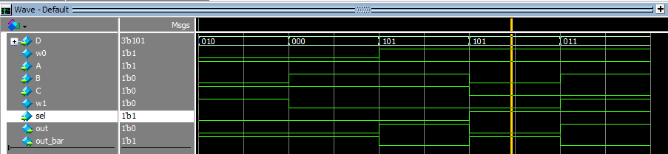

Figure 3: Q2 Code

Figure 4: Q2 Wave

**3)**

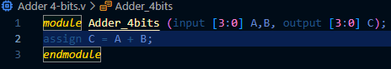



Figure 6: Q3 Wave

Figure 5: Q3 Code

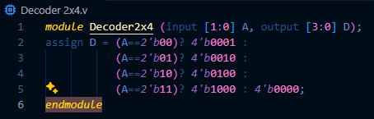**4)**

Figure 7: Q4 Code

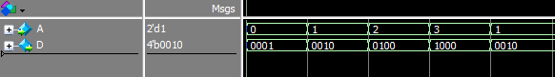

Figure 8: Q4 Wave

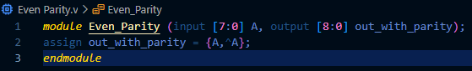**5)**

Figure 9: Q5 Code

Figure 10: Q5 Wave



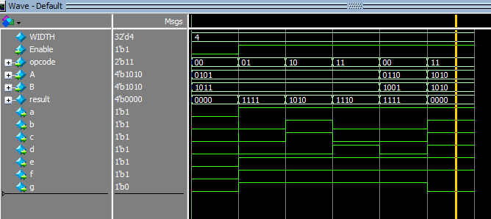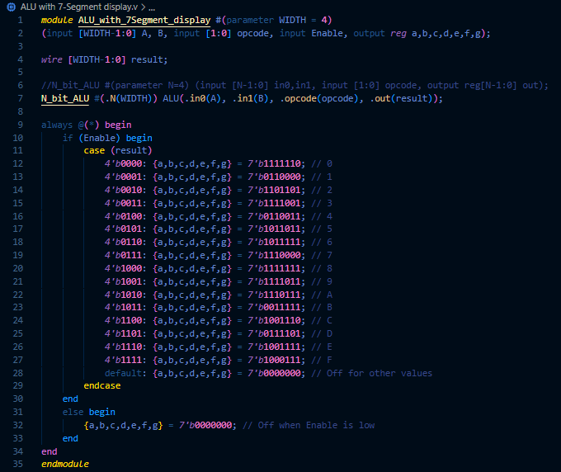**6)**

Figure 12: Q6 Wave

Figure 11: Q6 Code